Compiler Design  
Lab Exercise 13

short line

Ashwin Prakash  
RA1911026010048

**Aim: To implement Control Flow Analysis**

**Algorithm:**

1. The leaves of a graph are labeled by a unique identifier and that identifier can be variable names or constants.
2. Interior nodes of the graph are labeled by an operator symbol.
3. Nodes are also given a sequence of identifiers for labels to store the computed value.
4. If y operand is undefined then create node(y).
5. If z operand is undefined then for case(i) create node(z).
6. For case(i), create node(OP) whose right child is node(z) and left child is node(y).
7. For case(ii), check whether there is node(OP) with one child node(y).
8. For case(iii), node n will be node(y).
9. For node(x) delete x from the list of identifiers. Append x to attached identifiers list for the node n found in step 2. Finally set node(x) to n.

**Code:(Language : C)**

#include<stdio.h>

#include<string.h>

int i=1,j=0,no=0,tmpch=90;

char str[100],left[15],right[15];

void findopr();

void explore();

void fleft(int);

void fright(int);

struct exp

{

 int pos;

 char op;

}k[15];

void main()

{

 printf("\t\tINTERMEDIATE CODE GENERATION OF DAG\n\n");

 scanf("%s",str);

 printf("The intermediate code:\t\tExpression\n");

 findopr();

 explore();

}

void findopr()

{

 for(i=0;str[i]!='\0';i++)

  if(str[i]==':')

  {

  k[j].pos=i;

  k[j++].op=':';

  }

 for(i=0;str[i]!='\0';i++)

  if(str[i]=='/')

  {

  k[j].pos=i;

  k[j++].op='/';

  }

 for(i=0;str[i]!='\0';i++)

  if(str[i]=='*')

  {

  k[j].pos=i;

  k[j++].op='*';

  }

 for(i=0;str[i]!='\0';i++)

  if(str[i]=='+')

  {

  k[j].pos=i;

  k[j++].op='+';

  }

 for(i=0;str[i]!='\0';i++)

  if(str[i]=='-')

  {

  k[j].pos=i;

  k[j++].op='-';

  }

}

void explore()

{

 i=1;

 while(k[i].op!='\0')

 {

  fleft(k[i].pos);

  fright(k[i].pos);

  str[k[i].pos]=tmpch--;

  printf("\t%c := %s%c%s\t\t",str[k[i].pos],left,k[i].op,right);

  for(j=0;j <strlen(str);j++)

   if(str[j]!='$')

    printf("%c",str[j]);

  printf("\n");

  i++;

 }

 fright(-1);

 if(no==0)

 {

  fleft(strlen(str));

  printf("\t%s := %s",right,left);

 }

 printf("\t%s :=  %c",right,str[k[--i].pos]);

}

void fleft(int x)

{

 int w=0,flag=0;

 x--;

 while(x!= -1 &&str[x]!= '+' &&str[x]!='*'&&str[x]!='='&&str[x]!='\0'&&str[x]!='-'&&str[x]!='/'&&str[x]!=':')

 {

  if(str[x]!='$'&& flag==0)

  {

  left[w++]=str[x];

  left[w]='\0';

  str[x]='$';

  flag=1;

  }

  x--;

 }

}

void fright(int x)

{

 int w=0,flag=0;

 x++;

 while(x!= -1 && str[x]!= '+'&&str[x]!='*'&&str[x]!='\0'&&str[x]!='='&&str[x]!=':'&&str[x]!='-'&&str[x]!='/')

 {

  if(str[x]!='$'&& flag==0)

  {

  right[w++]=str[x];

  right[w]='\0';

  str[x]='$';

  flag=1;

  }

  x++;

 }

}

**Output:**

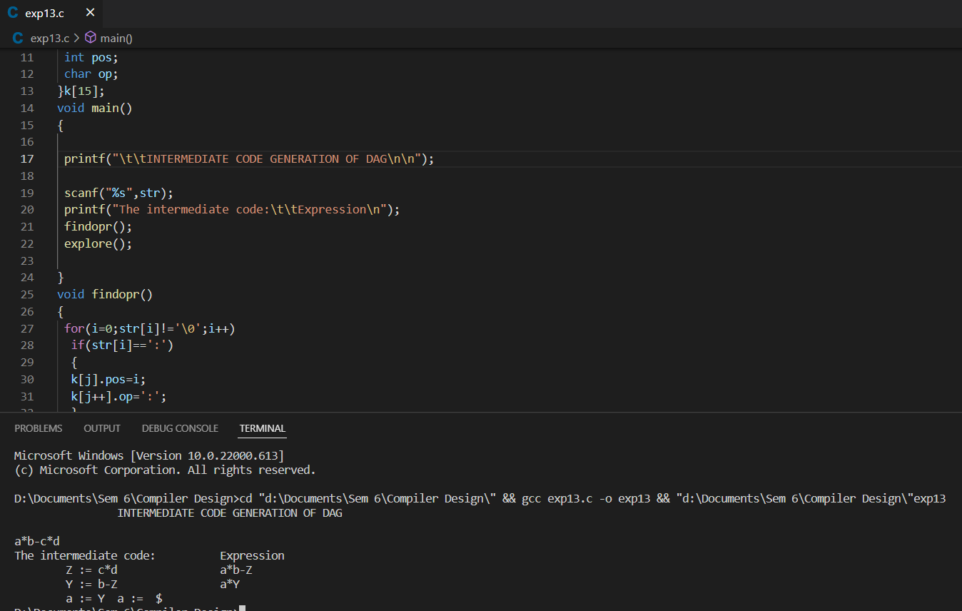

**Result:** Implementation of Control Flow Analysis has been completed and verified.